|  |  |  |  |  |  |
| --- | --- | --- | --- | --- | --- |
| Date | 22-Nov-22 | | | Tester Name | Shahabuddin Syed |
| Environment | Penfax - Test | | | Login used |  |
| Operating System | Windows | Version: | Update: | | |
| Software Used | Edge | Version: | Update: | | |
| Not Applicable | Version: | Update: | | |
| Release version | 22.4.1 | | | | |
| Title | Legal Order | | | | |
| Test Type | Regression | | | | |
| Test Scenario | Add a Legal Order | | | | |
|  |  | | | | |
| Expected Results |  | | | | |
| Pass/Fail | Pass | | | JIRA# | N/A |

Describe your steps with screenshots:

Search for any member in the PEPP Plan

Click on their stakeholder ID Number

Select Stakeholder ID - 238237

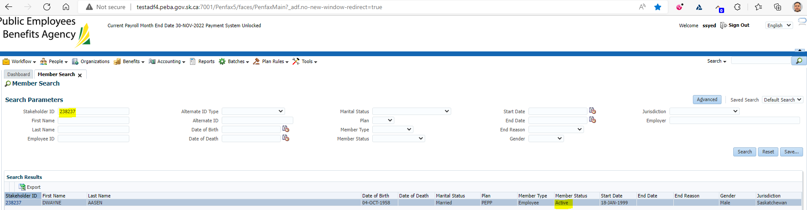

Click on Stakeholder ID - 238237

Click on Legal Orders

Under Legal Order click ADD

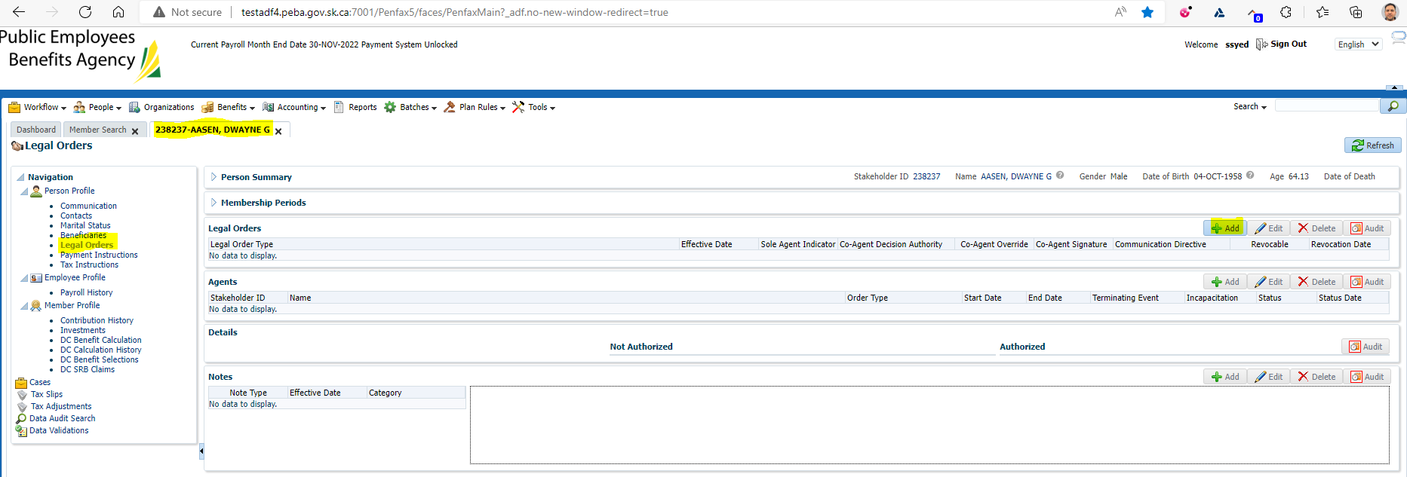

Need to fill entries with all the mandatory fields and the required fields

Input new details  
Hit Save

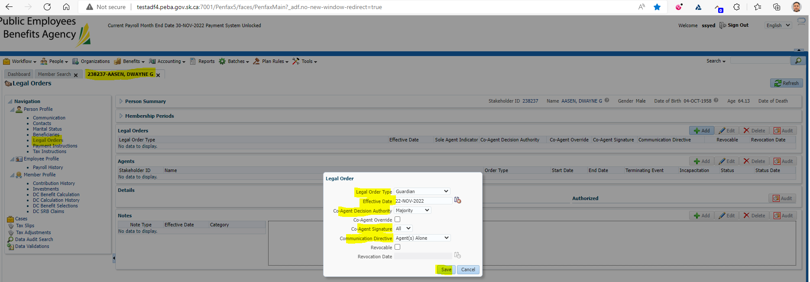

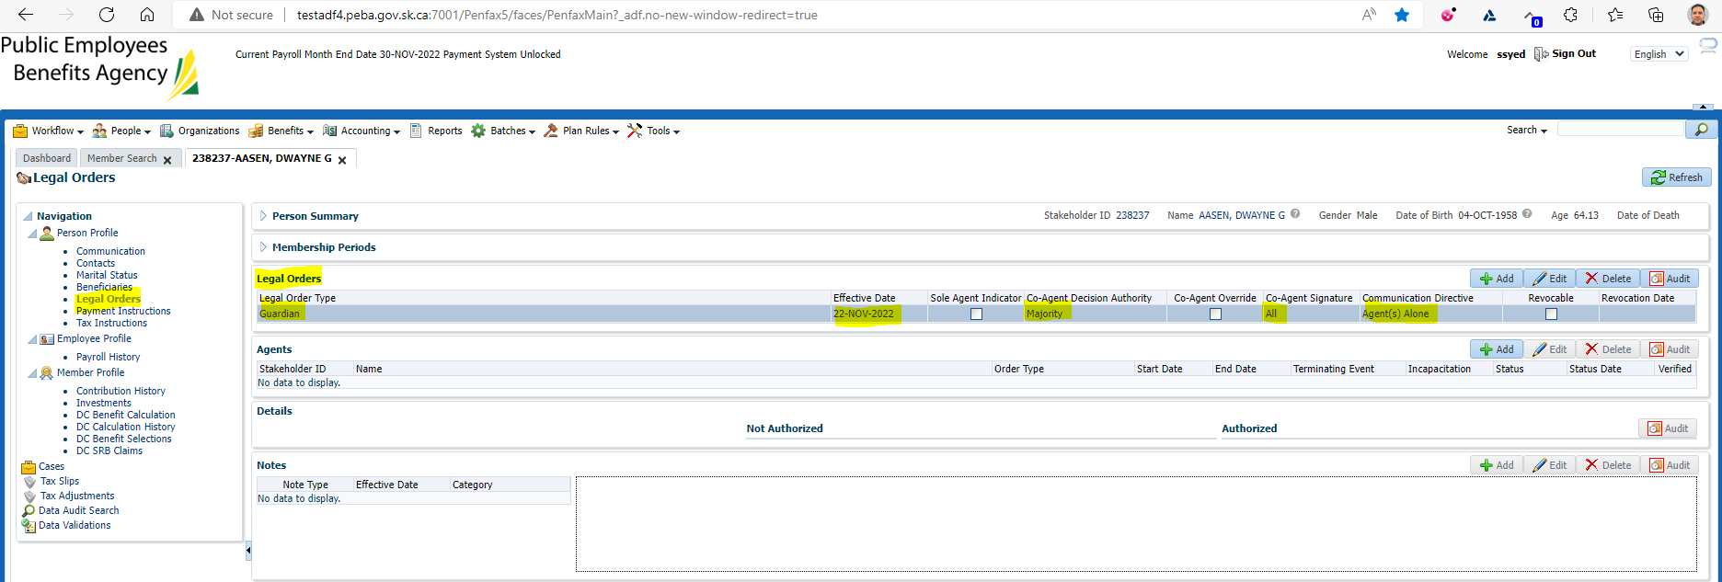

Under Agents Click Add

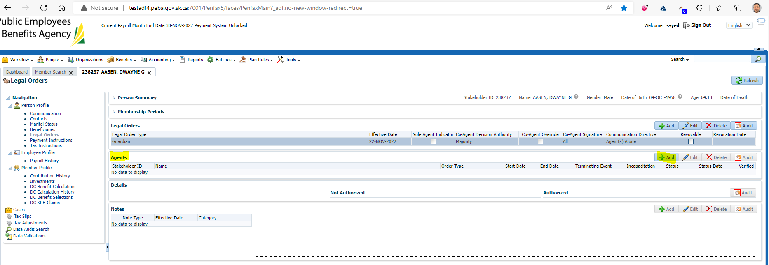

Under Stakeholder ID input a stakeholder or search for one.   
Under Order type select power of attorney  
Input a start date  
Leave End date Blank  
Under terminating event Select Death of agent  
Under Incapacitation Select Enduring  
Under status select approved  
Under status date input a date  
Under Not Authorized select beneficiary designation contact information payment instruction change and move them over to the authorized field.   
Click Save

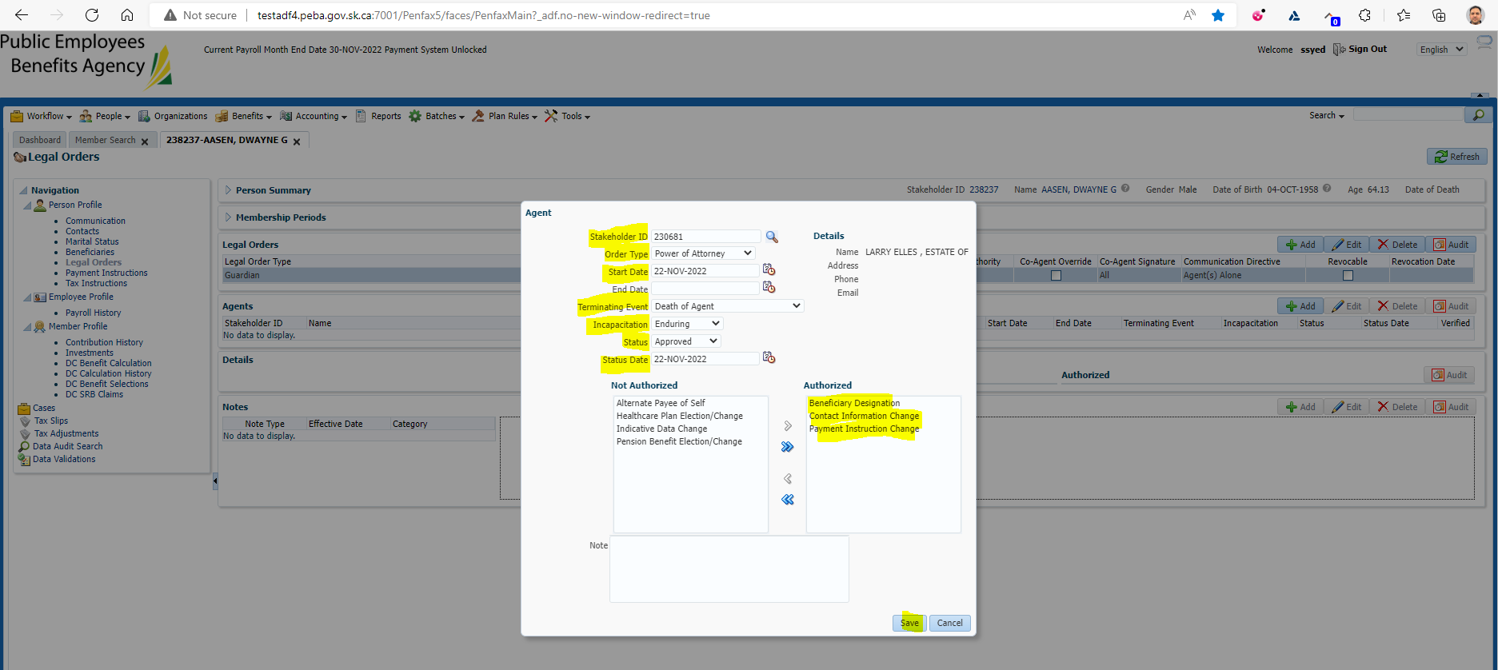

Need to verify with the updated legal order Under Agents

sssss